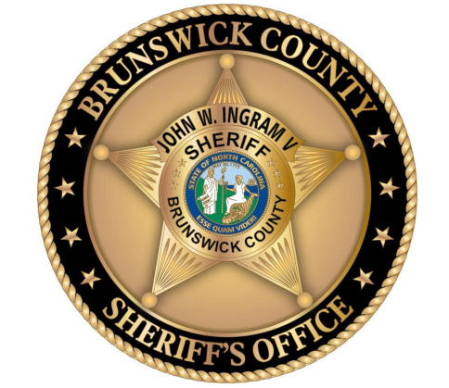

Volunteer Services Program

“Making a Difference Together Every Day!”
WHAT IS A CITIZEN VOLUNTEER?
A Citizen Volunteer is a member of the community who provides support services to the Brunswick County Sheriff’s Office without monetary benefit. Services typically included those listed below.

MISSION STATEMENT
It is the mission of the Brunswick County Sheriff’s Office Volunteer Services Program (VSP) to provide a variety of support functions to the Sheriff’s Office and the citizens of Brunswick County in an effort to enhance the work of sworn officers and civilian personnel for the betterment of Brunswick County.

2019 ACCOMPLISHMENTS
During the 2019 calendar year 315 volunteers contributed 36,878 hours of service at a value to Brunswick County taxpayers of $1,032,584

ADMINISTRATIVE SUPPORT
Administrative Support includes greeting the public, answering telephones, assisting with fingerprinting at the Bolivia Headquarters as well as at the Sub-Stations in Calabash and Bellville; assisting the Records Section with filing and organizing required files for retention; organization and establishment of formal case files; Support for the Detective Division; and other administrative functions at the Bolivia Office. Orientations are mandatory for these requirements.

DETENTION CENTER
Volunteers are assigned to assist Deputies at the public entrance to the Detention Center. The assigned task is to screen and process (using the computerized access control system) visitors and their possessions to ensure no contraband is introduced to the Detention Center and provide other assistance to the public in conducting business at the Detention Center. This includes visitors to inmates, attorneys, and bail bondsmen to name a few. Volunteers also assist with administrative duties and the inmate mail room in support of the Detention’s Center’s Operations. There is NO inmate contact while performing this duty.
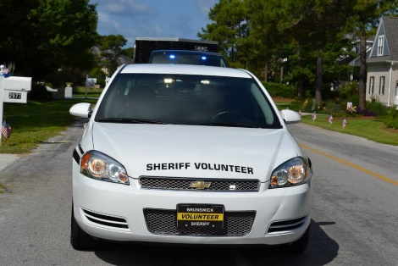
VOLUNTEER OBSERVERS IMPACTING COMMUNITY EFFORTS (V.O.I.C.E.) CITIZENS PATROL
The V.O.I.C.E. Patrol program is designed to operate as “eyes and ears” to supplement the efforts of Uniformed Services Division sworn law enforcement deputies. It operates as a mobile community watch throughout the County. The V.O.I.C.E. Citizens Patrol program focuses on low crime neighborhoods that often do not receive as much patrol coverage from sworn personnel as other areas of the County.
Each shift (4-hours) is conducted by two (2) volunteers and is based on a prepared Patrol Plan that is reviewed and approved by the IMPACT Team. VOICE members are expected to conduct a minimum of one (1) four (4) hour patrol each month. There are currently seven (7) VOICE Patrol cars in service, two in Bolivia, one at St. James, two at the Bellville sub-station and two at the Calabash sub-station.
A V.O.I.C.E. training class consisting of 8 hours of classroom and two (2) four hour training patrols with a certified VOICE trainer, within 60 days of classroom training, is required prior to certification as a VOICE volunteer. The training includes BCSO policies and procedures, orientation to patrolling, observation techniques, defensive driving, traffic control procedures, a driver safety course, and personal safety practices. Volunteers possess no law enforcement authority, are not permitted to confront citizens and may not possess weapons of any kind while on duty.

COURTHOUSE
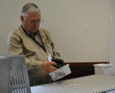
Volunteers are screened through a selection process and an orientation to the County Courthouse, its operation, and the basics of what volunteers could contribute prior to being accepted for this duty. Volunteers assist Courthouse Deputies at the main entrance with screening and greeting people with business at the Courthouse. Since inception in August 2011 volunteers have staffed the front entrance, with an assigned Deputy, from 8:30 AM until 5:00 PM on almost every day the Courthouse is open. This has resulted in the elimination of the need to call in deputies to assist the Bailiffs on heavy case load days. This directly supports a primary goal of the Volunteer Services Program to allow for sworn law enforcement personnel to focus more on law enforcement duties while volunteers fill non-law enforcement functions.

COMMUNITY OUTREACH AND SPECIAL EVENTS
BCSO volunteers participate in numerous community and special events during the year, including, but not limited to;
- D.A.R.E. Camp and D.A.R.E Graduations at the Elementary Schools.
- STARS Camp.
- Golf Cart Registration at various locations.
- The NC 4th of July Festival in Southport in July.
- The Brunswick County Fall Festival at the Government Complex.
- Numerous community Spring and Fall Festivals County wide.
- Christmas Parades and Festivals at Calabash, Shallotte, Oak Island, Leland, Bolivia and Southport.

UNSOLVED CASES TEAM
A specialized group of volunteers supports the Detective Division by reviewing unsolved case files to help determine if there are reasons to further investigate each case. This group requires specialized former law enforcement investigative experience with local, State or Federal agencies. Their focus is to bring new sets of eyes to unsolved cases, sometimes called “cold cases”, to further any potential opportunities to bring these cases to resolution. Volunteers on this team undergo a selection process, including oral interviews, by the Detective Division prior to acceptance.

INVOLUNTARY COMMITMENT TRANSPORTATION SUPPORT
Male and Female volunteers are on call supporting the Road Patrol Squads, to accompany their Deputies during transportation of patients that have been ordered committed to a mental health facility by legal or medical authority. Volunteers ride with a Deputy during these transport requirements at either 7:00 AM or 7:00 PM, going to various facilities throughout the State of North Carolina. When a transportation requirement occurs, this very important function ensures that only one Deputy is unavailable rather than two to that shift on the road in Brunswick County. These trips can range from 4 to 12 hours in length.

ANIMAL PROTECTIVE SERVICES
BCSO volunteers assist with the administration and operation of the Brunswick County Sheriff’s Animal Control Shelter on Green Swamp Rd. (Hwy 211). Volunteers submit an Animal Services application indicating their specific interest. These interests may include:
Adoption Fairs Cat Helper Dog Socialization
Event Planner Dog Walker Shelter Dog Training
Foster Parent Groomer Clerical Work
Shelter Greeter Transportation Social Media

MARINE PATROL UNIT
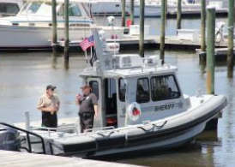
Volunteers began assignments with the Marine Patrol Unit aboard the unit’s largest boat in April 2013. The program has expanded to the unit’s smaller patrol boat. Working with a deputy, volunteers are prepared to handle all aspects of boat handling and crew duties as directed by the assigned deputy. They also assist the Unit Commander with maintenance and cleaning of the Agencies water crafts. To join this unit, providing you meet the below requirements, an interview and orientation patrol is required with the Marine Unit Commander.
Required qualifications:
- Graduate of the BCSO Citizens Academy
- Experience navigating and maintaining boats of 24’ length and above
- Completion of a USCG conducted or sanctioned boating safety course
- BCSO VOICE Citizens Patrol class, 8 hour classroom session
- Qualification trainings process by Marine Patrol Staff

Desirable Qualifications:
- 3-5 years recent boating experience including the last 2 years
- Knowledge of the waterways of Brunswick County (i.e. Cape Fear River, Intracoastal Waterway)
- Experience with marine depth finding, radar, and other navigation equipment

VOLUNTEER REQUIREMENTS.
- Completion of the BCSO Citizens Academy Course and submission of a completed Volunteer Program Application form to the Sheriff’s Office (The Citizen Academy application may be found at www.brunswicksheriff.com)
- Submit to finger printing, completion of a Volunteer Agreement and a Personal Data form. Active volunteers will receive email notices of volunteer opportunities on a periodic basis and may sign-up for these opportunities. Exceptions are VOICE Patrol, Marine patrol, 10-73 Transports, DWI or Courthouse, which all require special training and/or selection.
- Active volunteers that do not complete any volunteer hours within a three (3) month period will be placed on an inactive status. They may re-apply for active volunteer status by completing another Volunteer Program Application form and undergoing a new background check. Note: VOICE volunteers require a minimum of one 4 hour patrol each month.
- Volunteers will electronically submit a timesheet each month in which hours are performed by the 5th day of each following month.
- Volunteer polo shirts (replacing Citizens Academy shirts), will be provided after being processed as a Volunteer along with a Volunteer ID card. Additional Volunteer Services clothing (i.e. long sleeve shirts, jackets, caps, etc.) will be provided as needed, based on the type of duty being performed and the amount of volunteer time being provided. Uniform items including ID cards remain property of the Brunswick County Sheriff’s Office.
- Court House Volunteers are required to wear a long sleeve volunteer shirt and dressy black pants, NO cargo pants.
- New volunteers will be on probation for 60 days, after which they will be issued their additional uniform items.
- Uniform items that must be provided by the Volunteer are black pants (can be cargo pants), black belt, black shoes or black sneakers. Black shorts may be worn for some outdoor requirements during the summer.
- All Volunteers must present a neat and clean appearance.
- Citizen Academy shirts should be clean when returned to the Volunteer Director.

ADDITIONAL INFORMATION
Please visit www.brunswicksheriff.com or contact:
• Monique Stenquist, Director of Volunteer Services, (910) 253-2955 or bcsocontacts@gmail.com
• Lieutenant April Cherry agause.bcso@gmail.com

